LOADMASTER ENTERPRISE
ADDITIONS WEB POD PORTAL

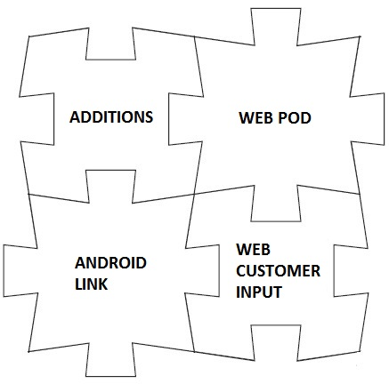

ZiPZAP Computers Limited
Commerce House
2 Carlton Boulevard
Outer Circle Road
Lincoln
Lincs
LN2 4WJ
www.zipzap.co.uk

‘ADDITIONS’ for Loadmaster - copyright ZiPZAP Computers Limited

This is a walkthrough document to cover concept and installation.

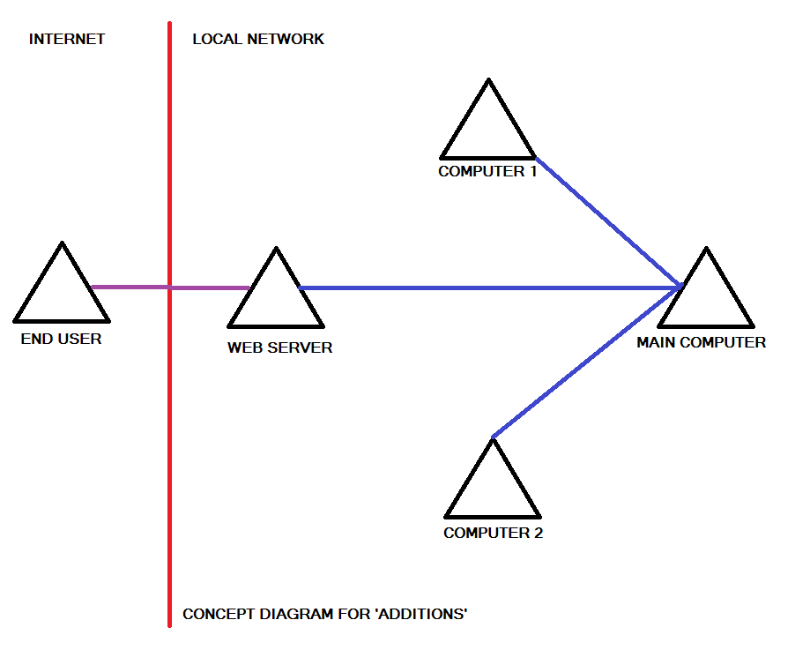

You will need a computer that can operate as a web server. Windows 7, 8 or 10 is perfectly acceptable as it is already built-in, but normally just turned off.

In this example the datafiles for Loadmaster are held on the MAIN COMPUTER on its local C: drive called LDATA. This directory is mapped by the three other computers as an L: drive. All the computers have Loadmaster loaded and can all see the data. Your will be different but the idea is the same.

You now need to set up IIS (Internet Information Server) on the WEB SERVER. IIS is just a standard web server and in reality any web server could be used that supports PHP.

Basic Web interface

This allows your customers to view their consignments using the internet in a reverse listing format for a specified period of days.

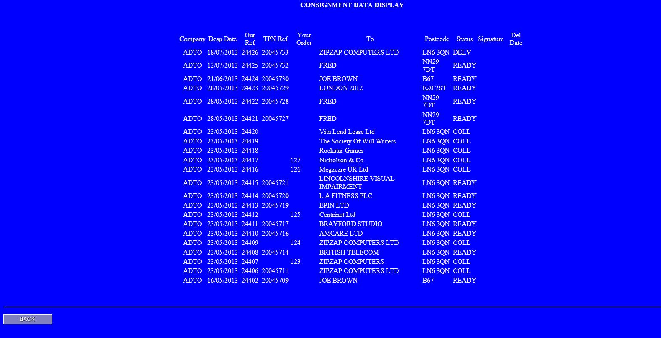

The column marked TPN Ref is optional.

The status codes are READY, COLL and DELV which mean ‘ready for collection’, ‘collected’ and delivered. If a signature has been obtained then this displays in the Signature column. The delivered date is shown in the Del Date column.

All customers can use this facility. You activate their use by completing the fields in their Loadmaster account setup which are marked as ‘web username’ and ‘web password’. Usernames should be unique.

The web server needs direct access to your data files to operate which means that you must set up a machine in your network to do this. It is quite simple under Windows 7, 8 or 10. You go into Control Panel and Windows Options then turn ON the Internet Information Server. The computer will need the PHP language installing, this is obtainable free from www.php.com and loads everything needed without requiring any user intervention.

Your router should redirect inbound HTTP requests on Port 80 to this computer. It is suggested that you give this computer a fixed IP address internally on the router.

Your firewall needs to allow these inbound requests.

In addition the web server computer will need either a fixed IP address or a dynamic IP host such as dyndns so that it can be discovered externally.

The computer should be loaded with Loadmaster and able to access the data. You then go Control Panel, Administrative Tools and ODBC. Add a DSN connection called LM which uses HyperfileSQL (preloaded with Loadmaster).

Then by dropping 3 files into c:\inetpub\wwwroot and altering the contents of one file the system is up and running.

You can hyperlink the web server from your web site or supply the URL to your customers. When they log in they will see this -

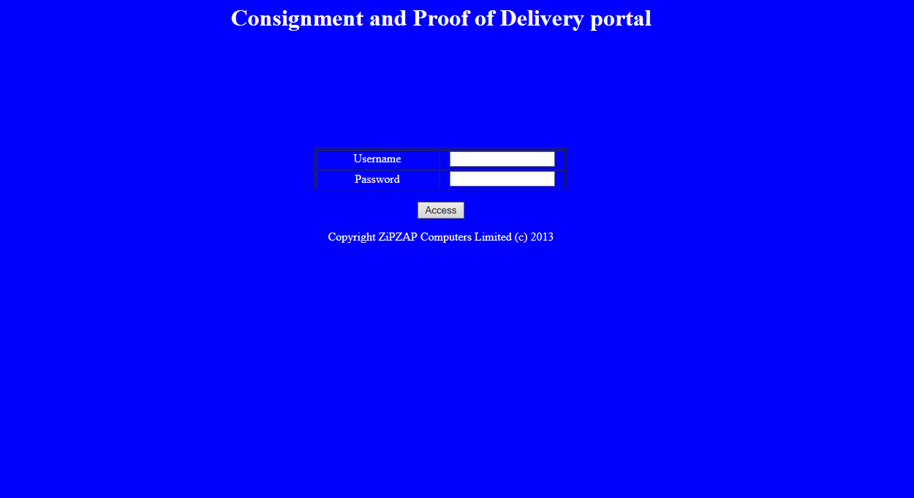

The information that the end-users see is deliberately restricted.

Installation. Go into Control Panel

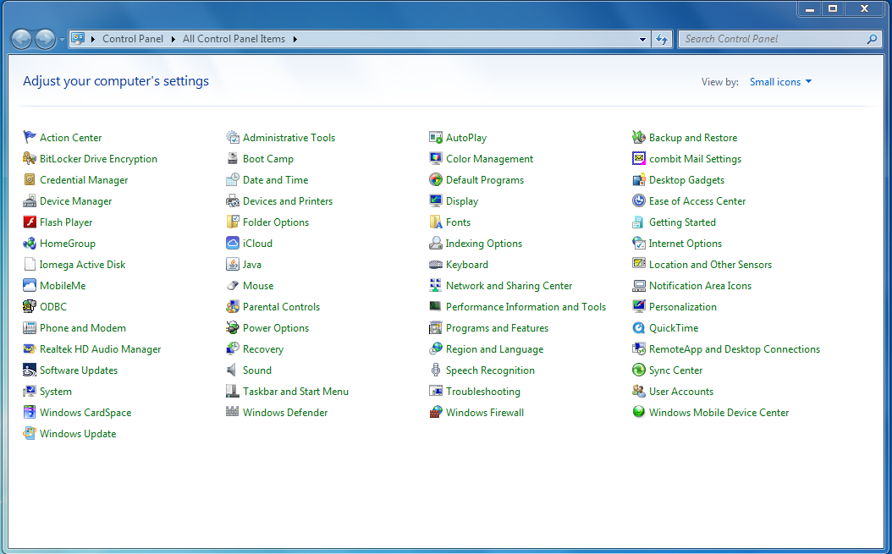

Click on Administrative Tools

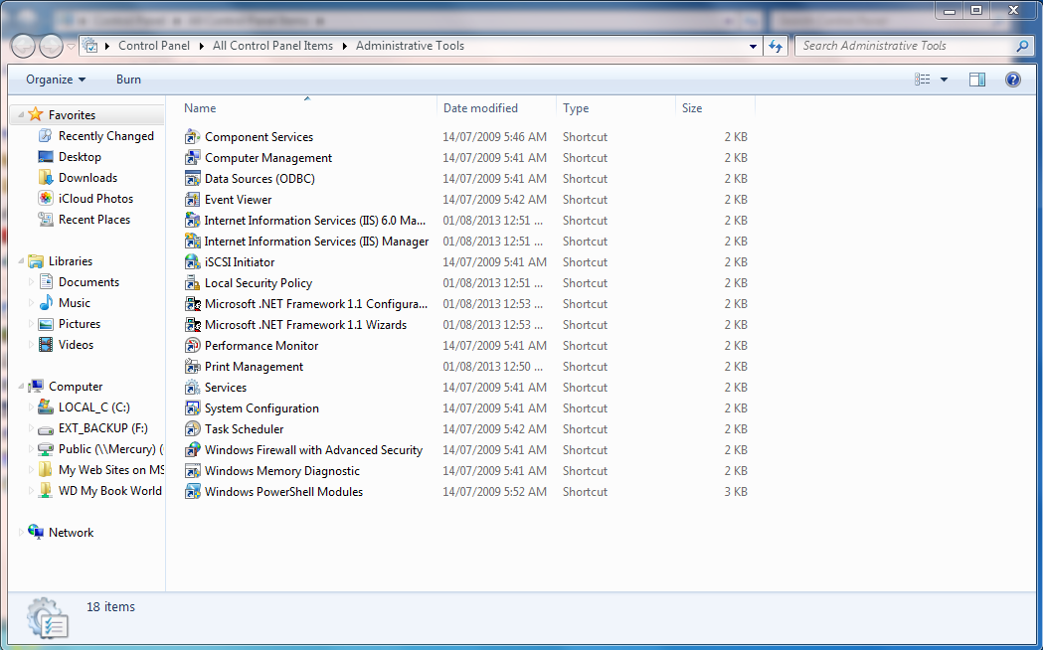
Click on Data Sources (ODBC)

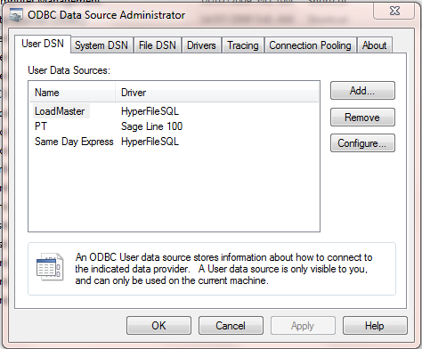

You will see items in here already. Click on System DSN

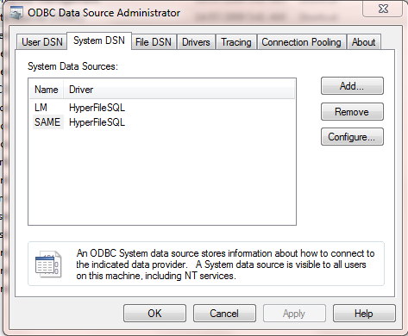

The above will be empty. Click on Add. Choose HyperfileSQL. Then set up as below.

Note that the full name of the Analysis will be different. It should be in C:\Program Files\Loadmaster\ or similar.
Just choose the file using [...] option. It is the only file with a .WDD extension.

The directory of files will be the data directory on your server. It will appear as the data directory within the local program.

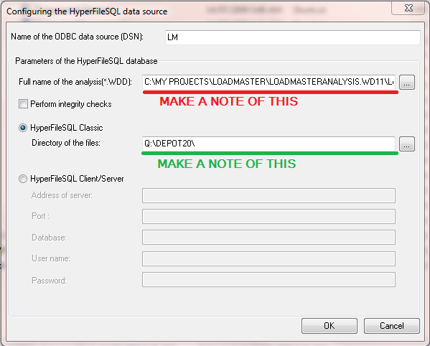

Make a note of these values. It will be used later.

In Control Panel go into the option of Programs and Features.

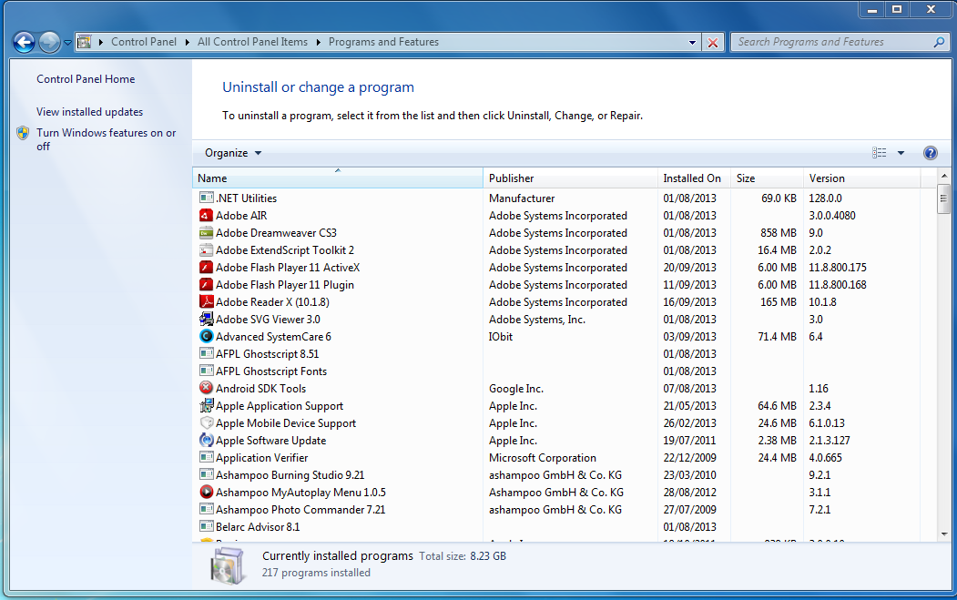

Click on the option of Turn Windows features on or off. Go to Internet Information Services and open the option.

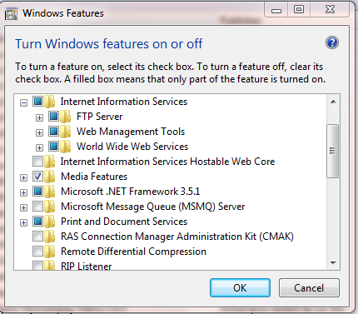

Click on the Management Tools sub-menu.
Turn these options ON.

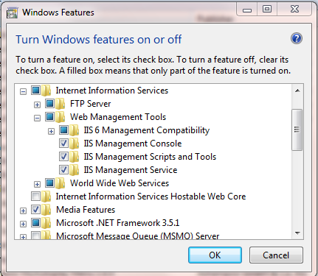

Then into the World Wide Web Services option.

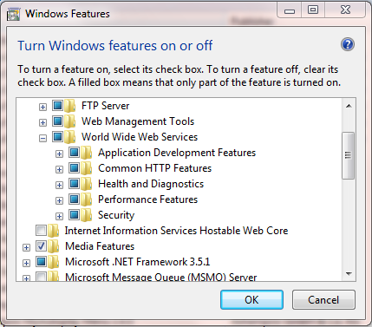

Turn these features ON.

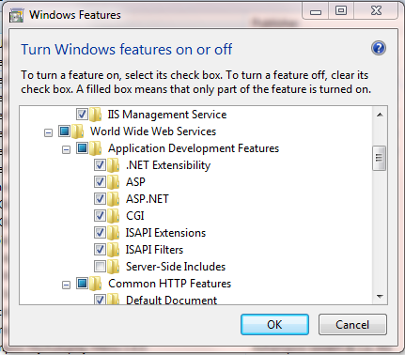

And these.

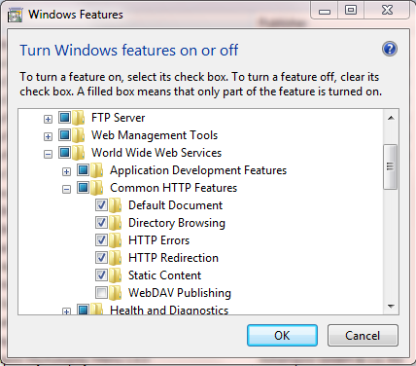

And these.

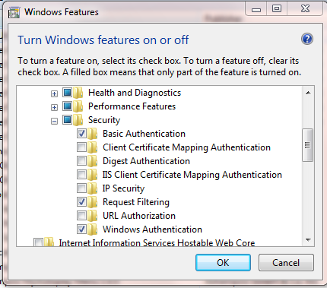

Save all.

Now go into Internet Explorer and type 127.0.0.1 on the address line. You should see this -


In Internet Explorer go to http://php.iis.net/ (or follow the instructions in POD-PHP-server-setup.pdf if using a later version of Windows)

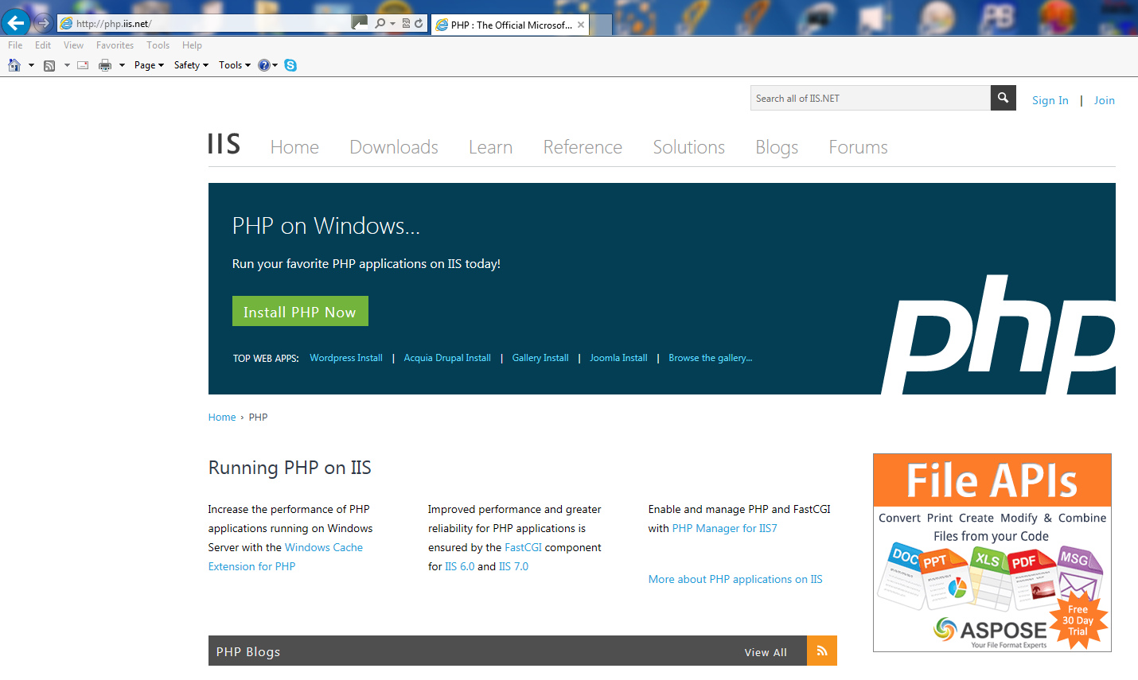

Click on the Install PHP Now button. Let this load. Go into Explorer and click on local disk C:

Go into Explorer and click on local disk C:

You should see something like this -

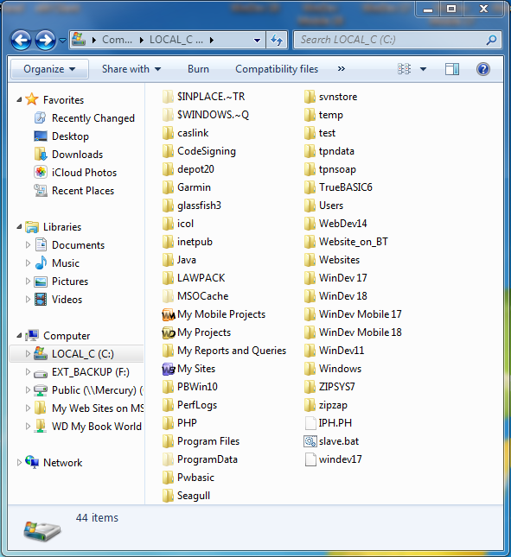

Click on Inetpub and then wwwroot

Copy the files we sent into this location.

This will be similar (but not the same) as this -

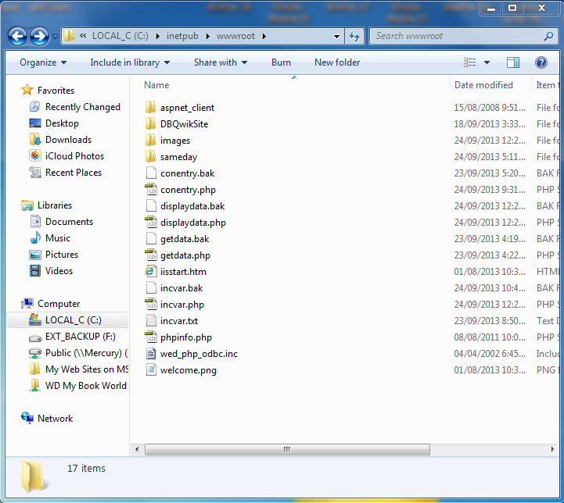

Right-click incvar.php and open in Notepad (choose ALL FILES option)

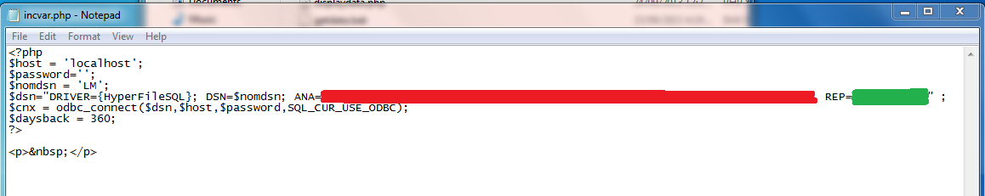

Amend the values shown in red and green to those from the ODBC connection. Here’s the previous screen again to remind you.

Save.

Go into Internet Explorer and type 127.0.0.1/phpinfo.php on the address line. You should see a screen full of information and not an error.

In Loadmaster pick an account and go into setup/accounts. Go to the web tab. Enter a unique username and password.

Go into Internet Explorer and type 127.0.0.1/getdata.php and you should get a screen asking for a username and password. Enter those you created and click on the Access button. You should now see the data from your program.
NOTE: If using a mapped drive then you may need to replace the location of the Hyperfile Classic directory to the URN equivalent i.e.\\Computername\DataDirectory

Here is an example of what the ODBC should look like -

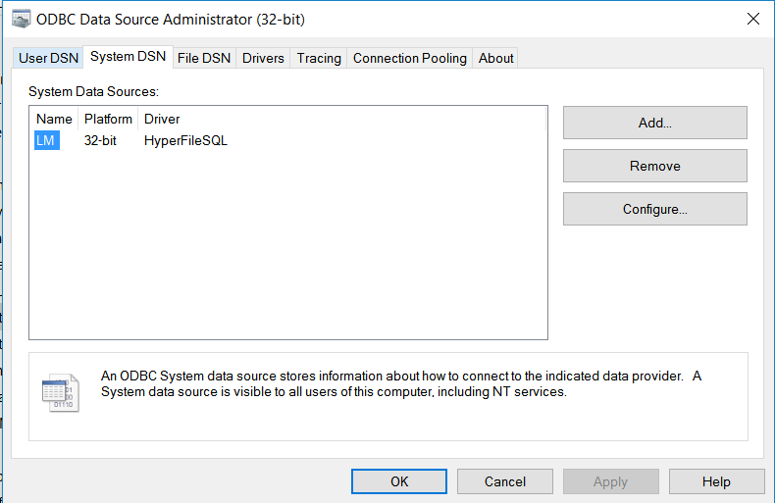

With the Data Source looking like this –

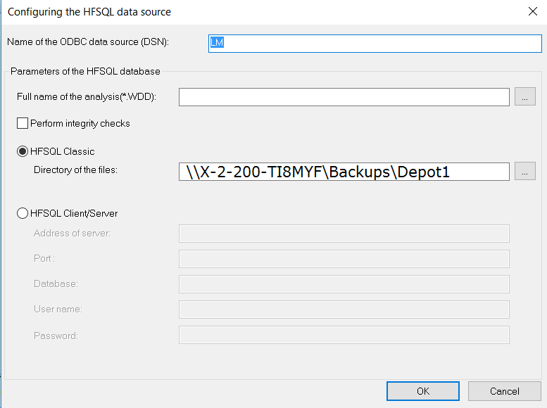

The directory of Files was originally T:\DEPOT1 . This is a direct URN equivalent.

BUT to get it to work with PHP in incrvar.php you need three backslashes after REP= (and not just 2). This is a quirk of PHP.

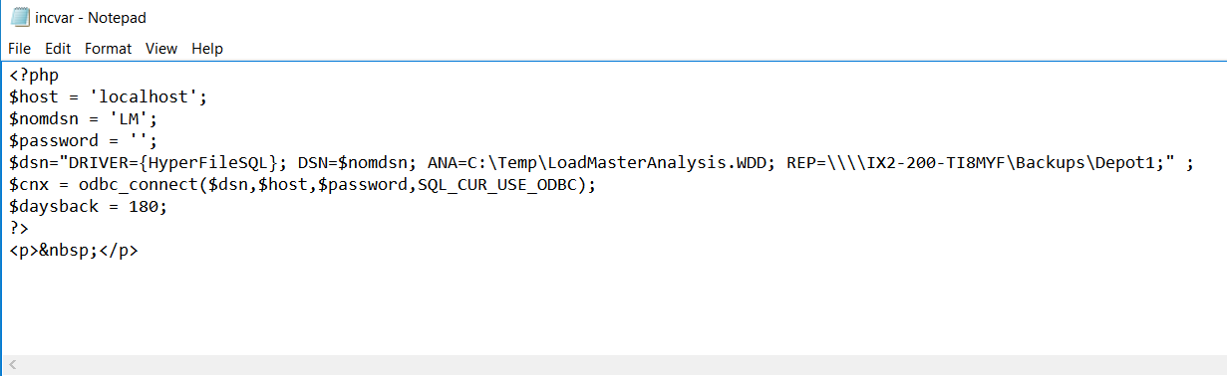

To get this all visible to the outside world you need -

1. either need a fixed IP address or a dynamically assigned address using something like dyndns (so you end up with something like mysite.dyndns.org that goes directly to the web server).
2. on your router fix the internal IP address of the web server e.g. 192.168.1.10
3. on your router allow inbound data on Port 80 and redirect to the web server computer
4. on your web site place a link for your customers to the web server

Web pages supplied -

getdata.php
displaydata.php
incvar.php
phpinfo.php

